FSA OE 2024 Instructions
To enroll in coverage:
- Log-in to Hornet HQ (http://www.hornethq.kzoo.edu)
- Select “Employee” in the upper left hand cover of the screen.
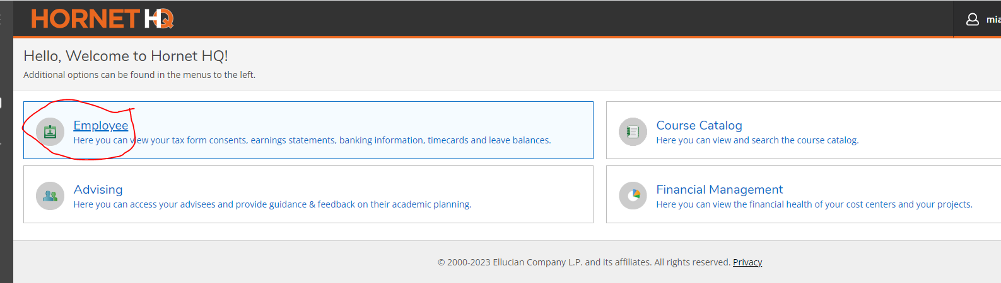
- Select “Benefits” in the lower right hand corner of the screen.
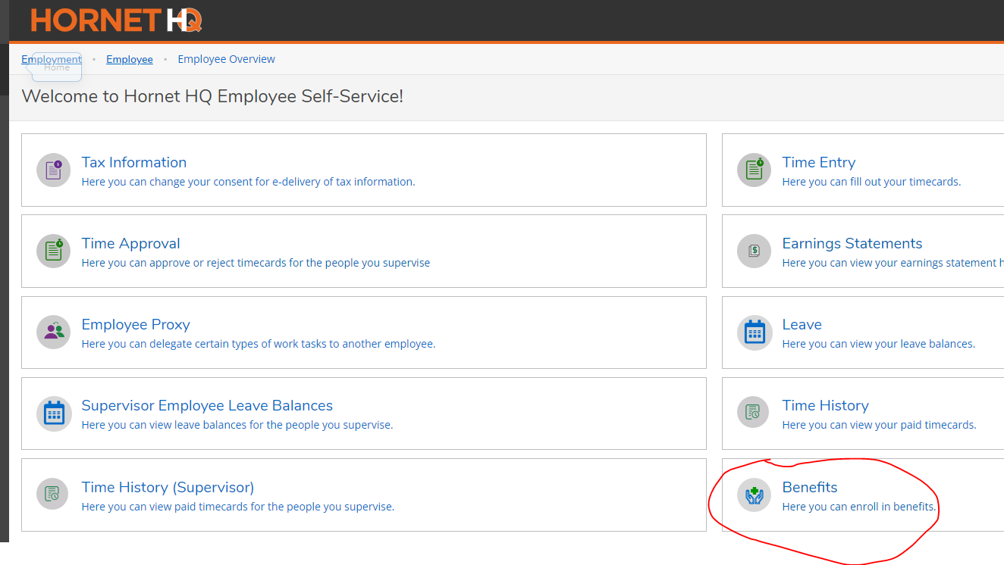
- For “Pending Elections” click on the blue “View & Modify” button.
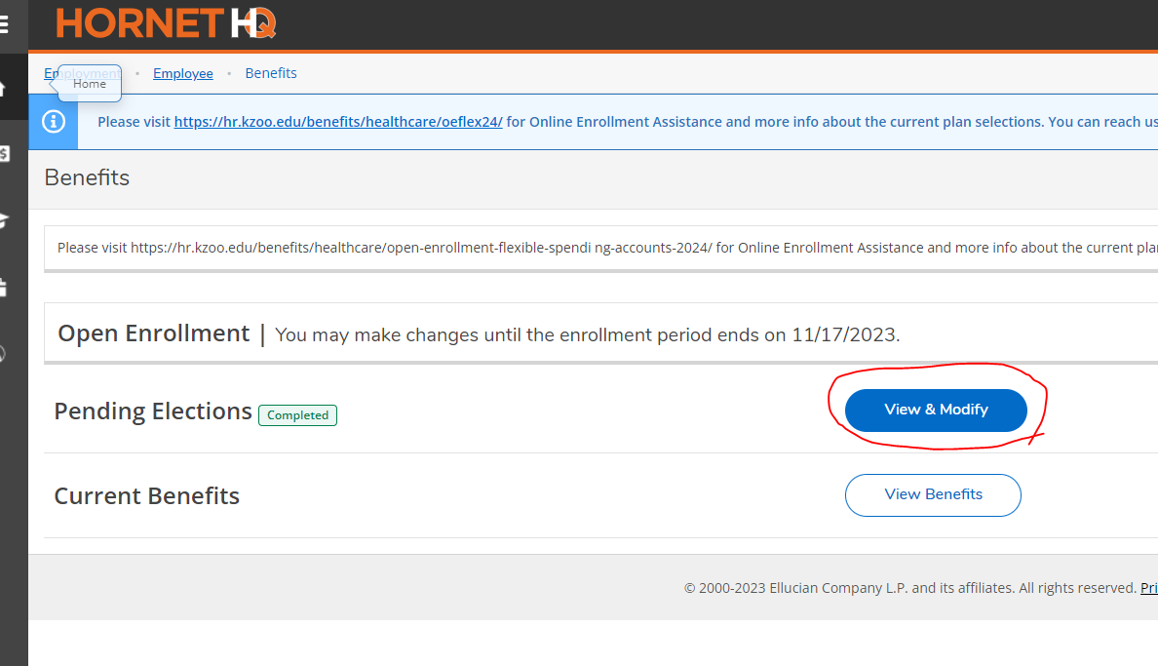
- You will have the option to either “waive this benefit” or click on “Choose a Plan” to enroll in the benefit. For this example, update the “Flex Spending Dependent” plan by clicking on “Choose a Plan.”
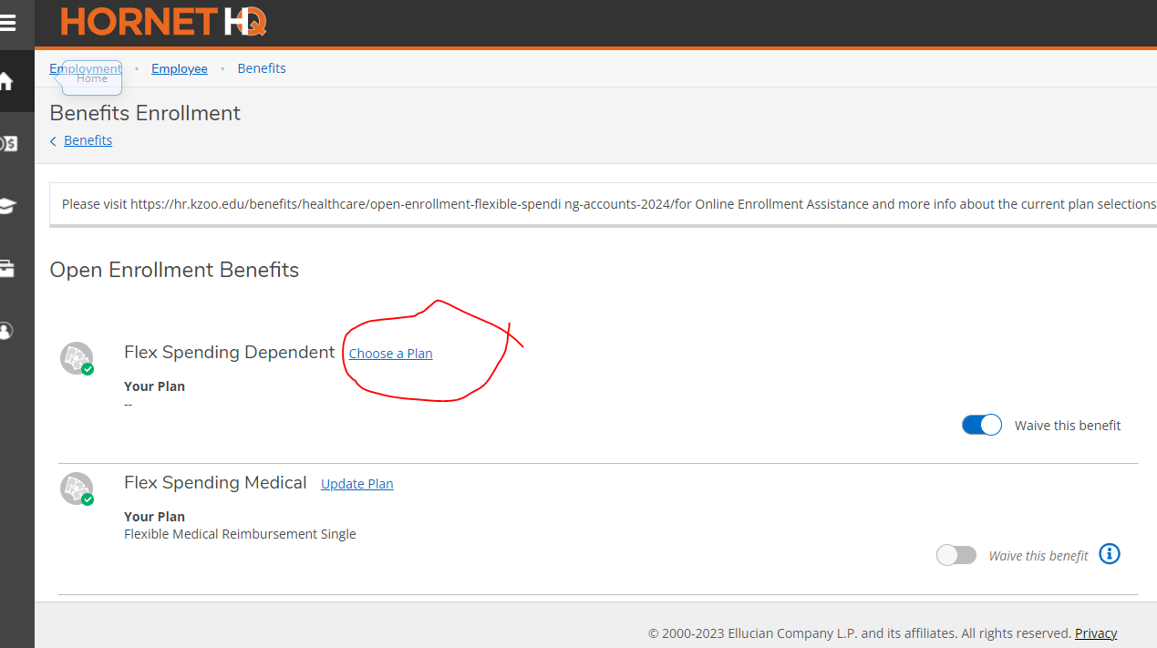
- Check “flexible dependent care” and then enter a dollar amount.
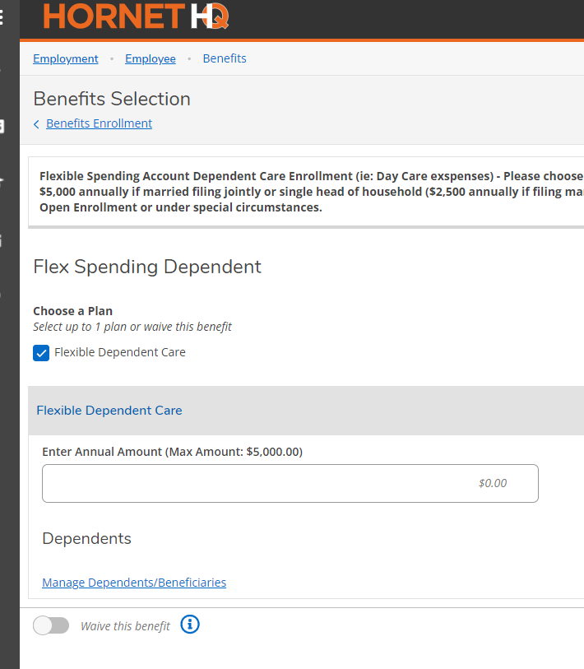
- To enter or manage dependents, click on “Manage Dependents/Beneficiaries.” Save changes. Click on “Add Another” and enter dependent information and save.
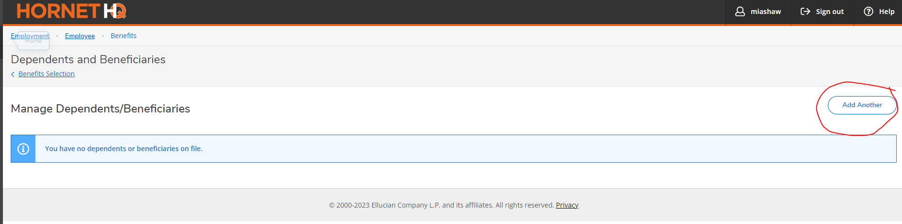
- In the upper left hand corner of the screen under “Benefits Selection” click on “Benefits Enrollment” this will take you back to the enrollment screen.
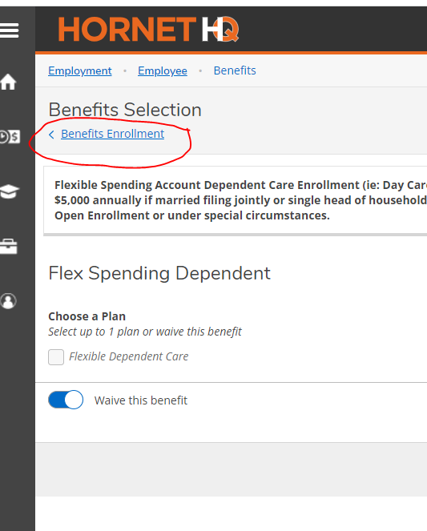
- Click “Choose a Plan” next to “Flex Spending Medical”.
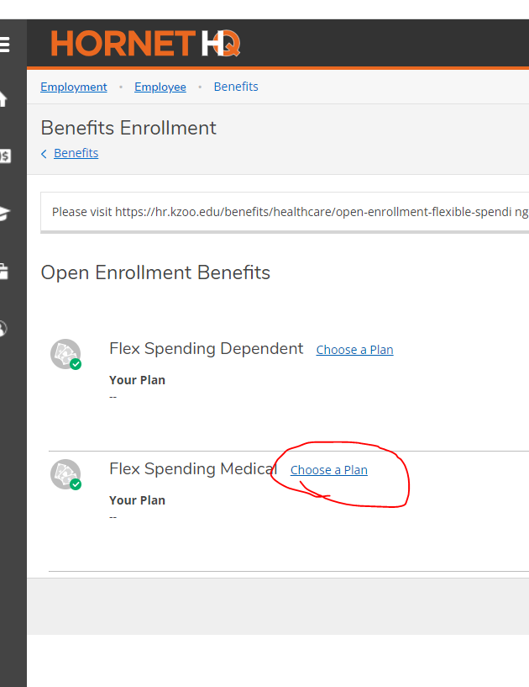
- Select either single or family reimbursement and enter a dollar amount. If you select family, you will be able to manage dependents following the steps outlined in step 6 above. Click save.
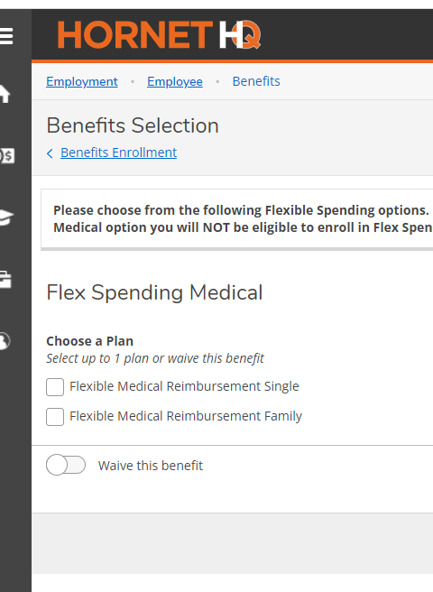
- In the upper left hand corner of the screen under “Benefits Selection” click on “Benefits Enrollment” this will take you back to the enrollment screen.
- In the Benefits Summary section on the right hand corner of the screen click “review and submit.”
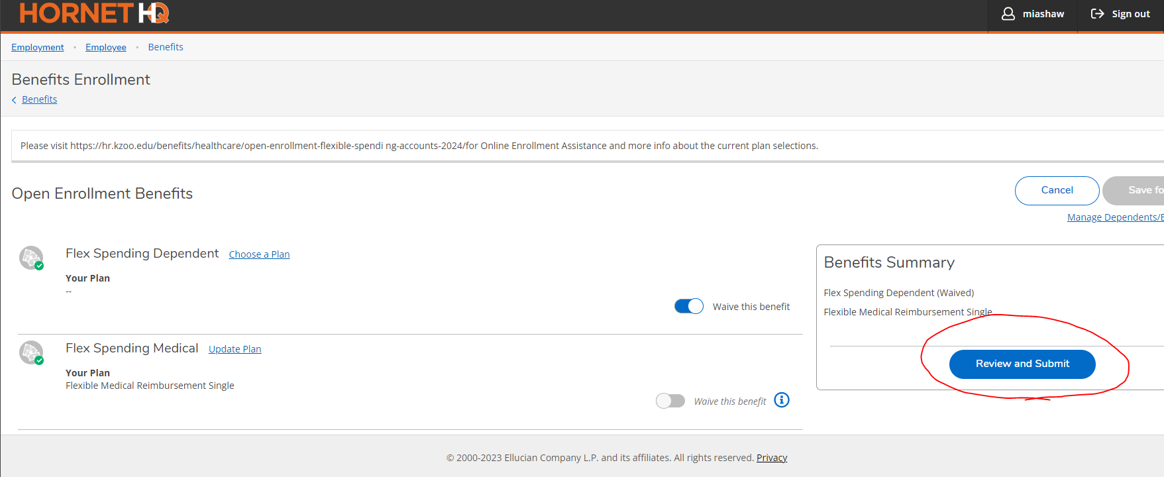
- Review your elections and the Terms and Conditions. If everything looks OK, click the “I have read and accepted these terms” box and then submit.
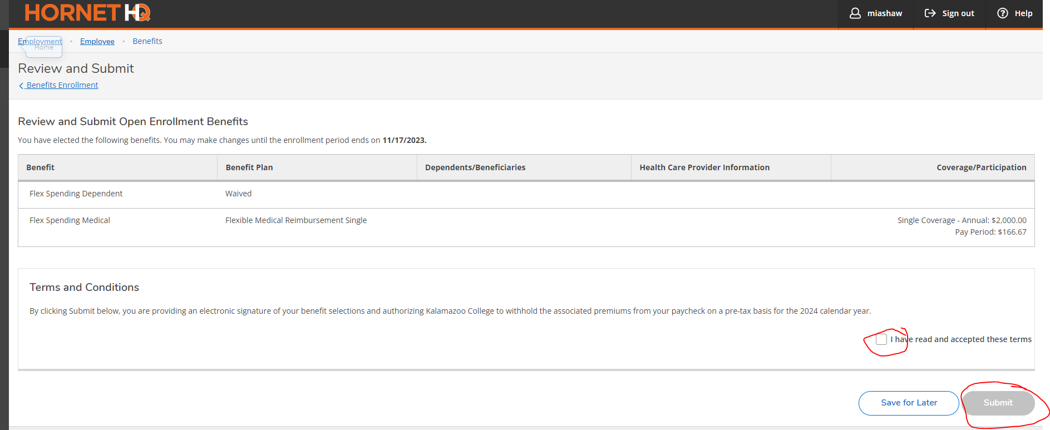
To waive/decline coverage
- Log-in to Hornet HQ (http://www.hornethq.kzoo.edu)
- Select “Employee” in the upper left hand cover of the screen.
- Select “Benefits” in the lower right hand corner of the screen.
- For “Pending Elections” click on the blue “View & Modify” button.
- To “waive this benefit” click on “Choose a Plan” to click on “waive this benefit”.
- Save your waived election.
- In the upper left hand corner of the screen under “Benefits Selection” click on “Benefits Enrollment” this will take you back to the enrollment screen.
- Repeat steps 4-6 for both plans.
- In the Benefits Summary section on the right hand corner of the screen click “review and submit.”
- Review your elections and the Terms and Conditions. If everything looks OK, click the “I have read and accepted these terms” box and then submit.

